PEACE TALK!
September, 2023

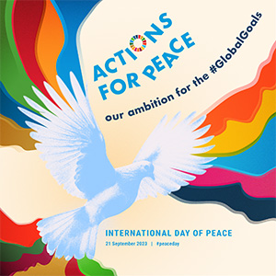

September 21st is the International Day of Peace! This United Nations holiday has been celebrated around the world since 1981. Each year a theme is selected to focus our work for peace. This year, we are being asked to take actions to forward peace – in our selves, in our families, and in our communities. The United Nations has developed a list of goals for the world to achieve before the year 2030. You can access the list by following this link:

THE 17 GOALS | Sustainable Development (un.org)

What does it mean to be sustainable? It means to live in such a way that causes little or no damage to the world around us so that it can last for a long time. It means to use natural resources responsibly so that they can support both present and future generations.

Here are some examples you might try:

Goal 3: Good Health and Well-being
There are many things that you can do to work for this goal: eat nutritious meals, get plenty of sleep, and look on the bright side of a situation for examples.

Goal 16: peace, justice and strong institutions (like school or Meeting)
Here are few ideas to get you started:
- Share your belongings with others
- Use water carefully, not wasting a drop
- Look at the Peace Pole, outside the Meetinghouse. Can you learn to say peace in another language? Perhaps you could make a poster like this!

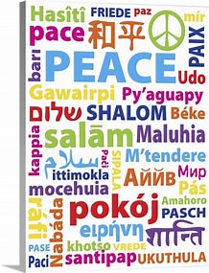

Talk over this list of 17 goals with your families and make a plan of action to work for sustainable development.

On Thursday, September 21st, it has become a tradition to observe a Minute of Silence at noon in every time zone. This PEACE WAVE will bring attention to our desire for a peaceful world in unity. If possible, set an alarm and join others in this action.

