Peace Talk! 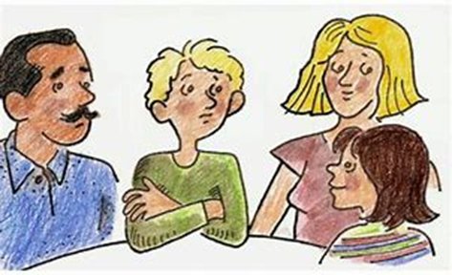
Theme: Peace in the Family
Mid- to late summer sometimes provides families with more than the usual amount of ‘together’ time. Squabbles and conflicts can become more frequent occurrences. Yet once we know some simple steps to take, we find we are empowered to work through the difficulties.
One of the simplest is a 5-Step model:
- Stop and listen.
- Ask questions.
- Brainstorm ideas to solve this problem.
- Choose one idea to try.
- Do it!
Here are helpful choices for older youth and adults who find themselves in a conflict.
- Think before reacting.
- Reach for common ground.
- Stay calm.
- Be patient.
- Imagine a variety of solutions.
- Surprise and humor may help the situation!
- Say or do the unexpected to change the mood.
- Expect the best.
Weekly family meetings can be a time to share what has been going well and also what has not. The whole family can be working towards solutions in this scenario. As with mediation, all who are present need to be on-board with resolving the issue, meaning they are not continuing to argue, blame, criticize.
To make the world a more just and peaceful place, we need to start with ourselves and our families.
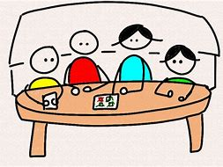

Resources: Creative Response to Conflict https://crc-global.org ; https://raisingchildren.net.au/grown-ups/family-life/routines-rituals-relationships/good-family-relationships; Alternatives to Violence Project https://avpusa.org

